Startup documentation for WebdriverIO

Requirements:

1. NodeJs

* You can download nodejs in this given link <https://nodejs.org/en/download>

1. Java 8+ Version

* You can download Java in this given link <https://www.java.com/download/ie_manual.jsp>

1. VS Code IDE

* You can download VS Code in this given link <https://code.visualstudio.com/download>

Now open your nodejs cmd terminal

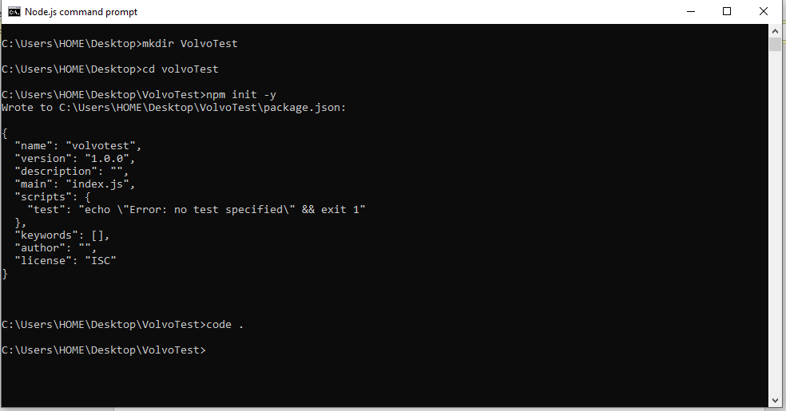

1. Go to a specific folder by using cd ( change directory )
2. Use Mkdir to create a folder
3. CD to the folder that you’ve created
4. Type npm init -y

* Npm init -y is for you to create a package.json where you will see the libraries that you’ve install to use in the components.

1. You’ll use the code . if you want to open the vs code.
2. Type npm init wdio

* 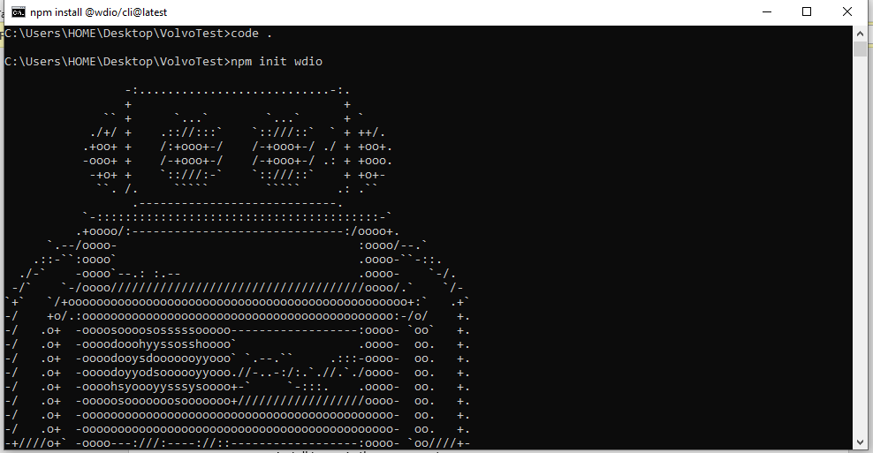It means you’re creating a project in WebDriverIO.

1. You’ll see this questions it means you need to setup your WebDriverIO.

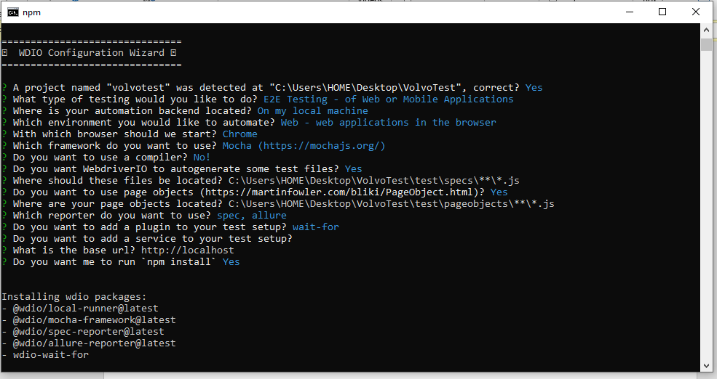

* A project named “ volvotest “ was detected at “ C:\users\HOME\Desktop\VolvoTest”, correct? (Y/n)
*  Just press enter or put y it will automatically Yes It was just a double checking of the folder name.

* We will choose the E2E, it means end to end testing. Just press enter

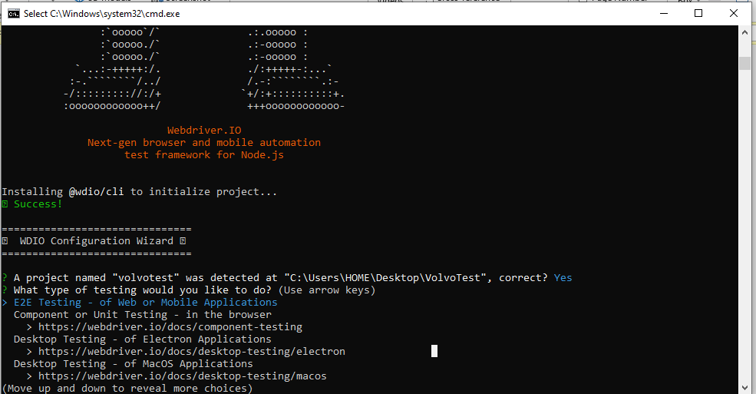

* 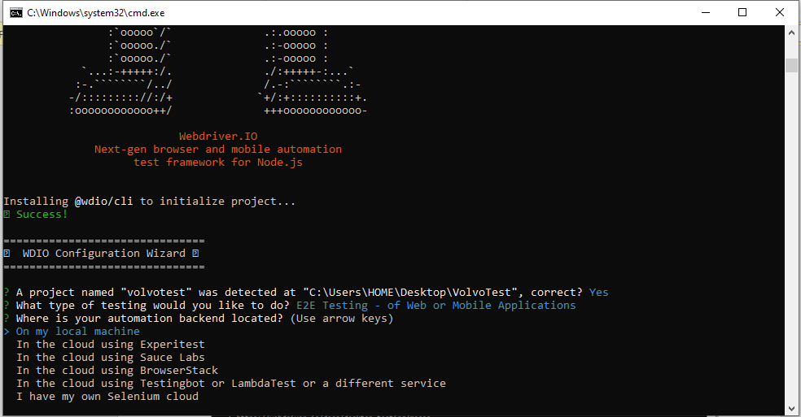Since this is for local and from the scratch project we will choose the “On my local machine“
* 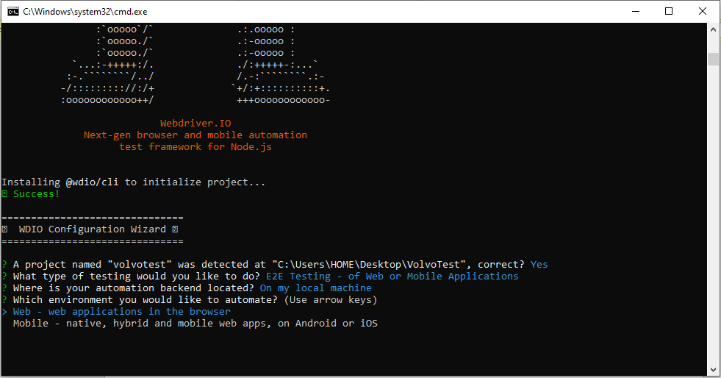Now it depends if what kind of development you will test if it’s Web development or Website or Mobile application. But since we are using website , we will choose the Web.
* 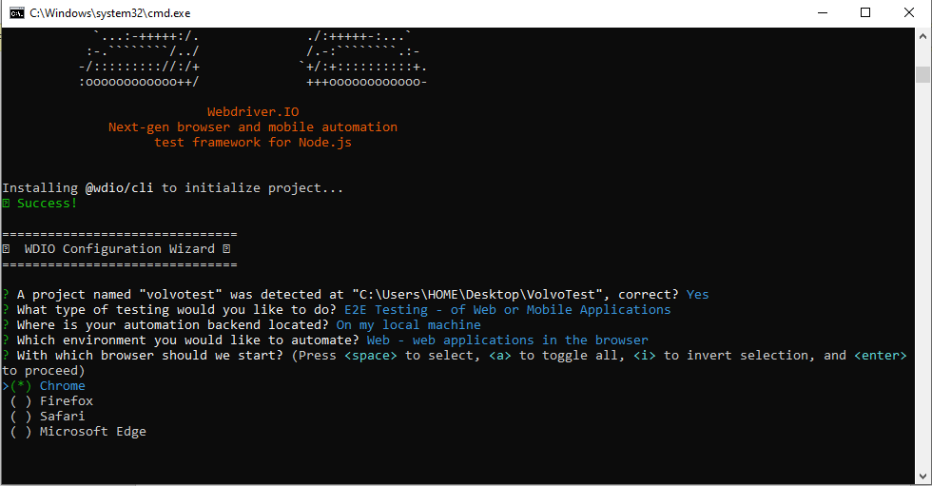Now it also depends on what browser is your prefer. Choose on what you commonly used. On my side I use Chrome most of the time.

* 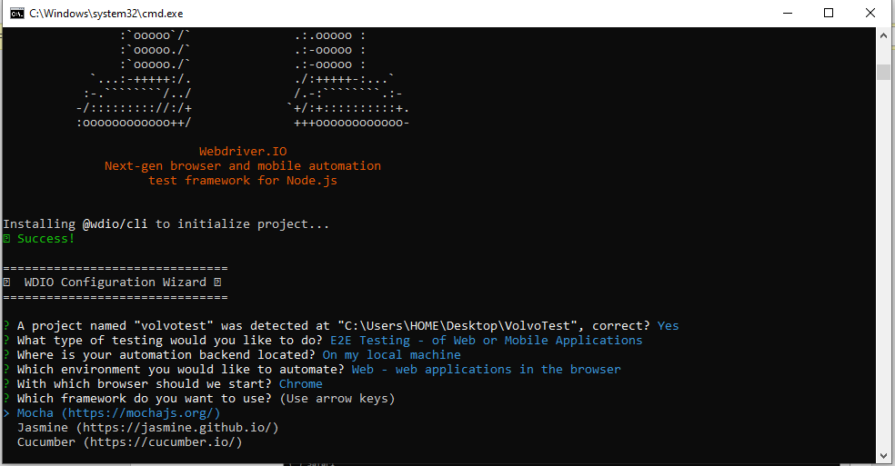This Mocha , Jasmine and Cucumber is all javascript testing framework. For me I used Mocha but you can use any framework you’re confident with.
* 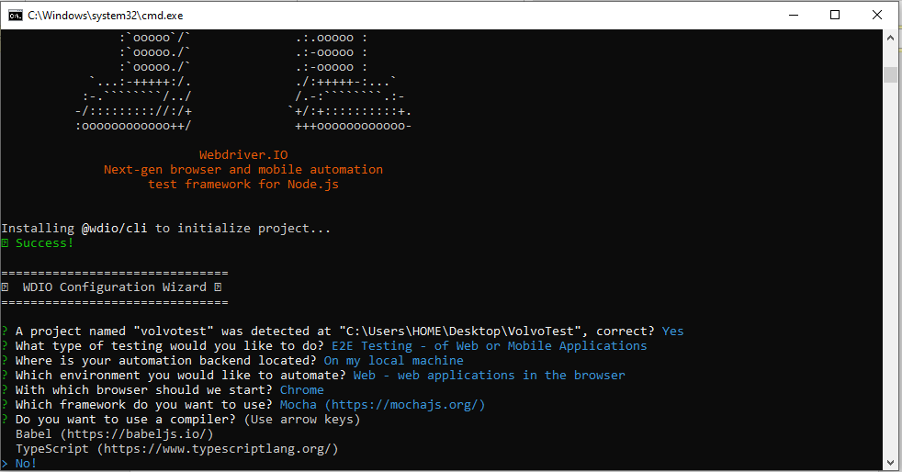I will use the default compiler so I’ll choose No
* 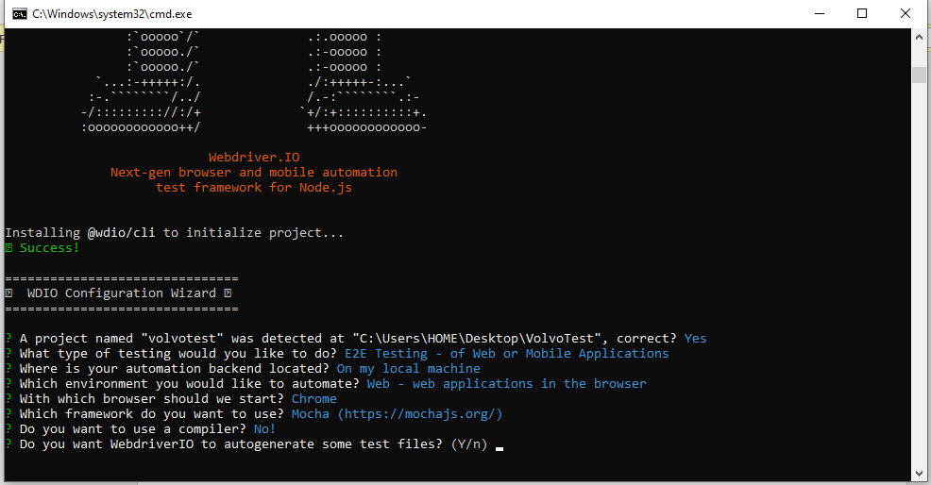Type Y or press enter so it will autogenerate a file
* 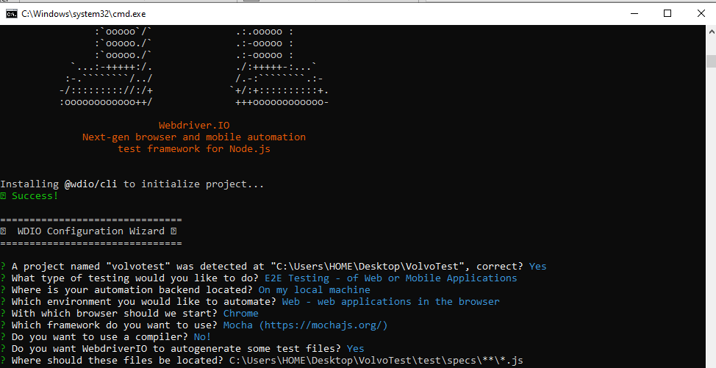I’ll go by default so just press Enter
* Press enter because we are using page object
* 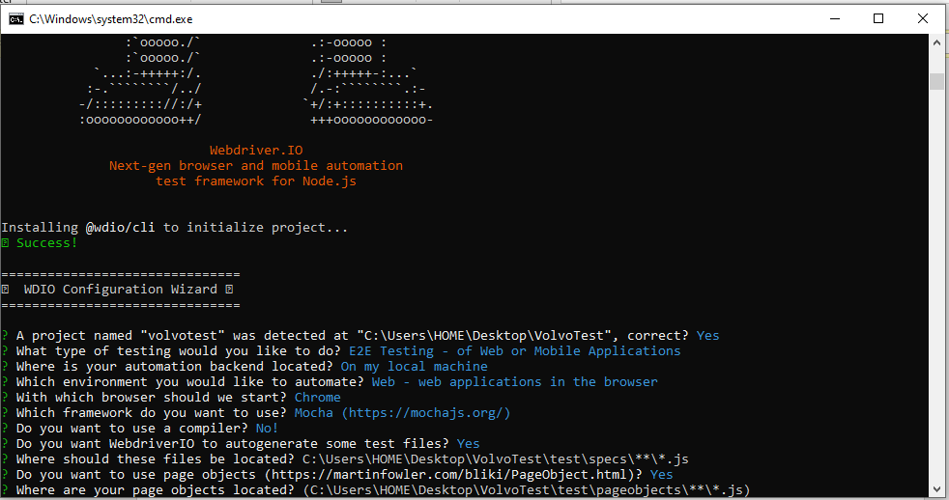Press enter for default
* Add the Spec and Allure so we can have a report and result regarding on our test specially it’s important to know the result of your testing on what line you failed to run and the graph of it and a lot more.
* Spec is the default reporter.

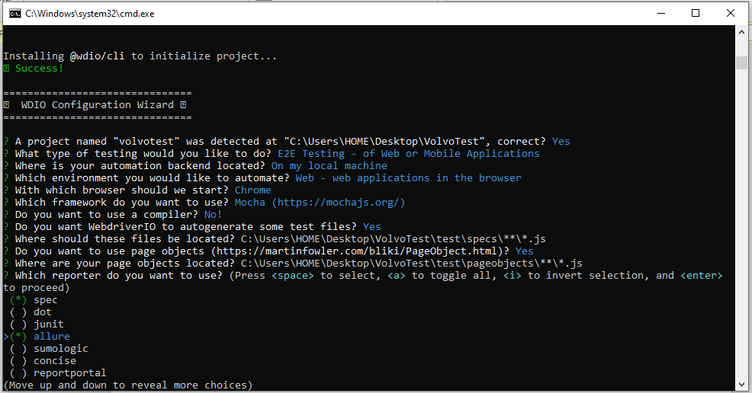

* 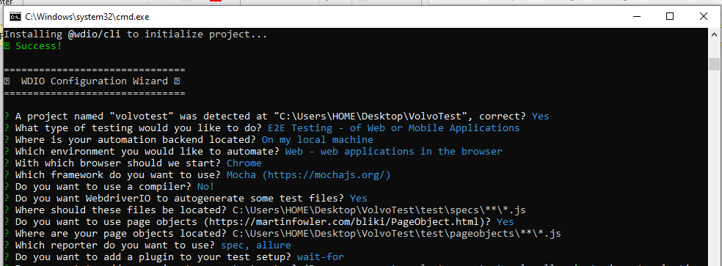Use the wait-for for default
* 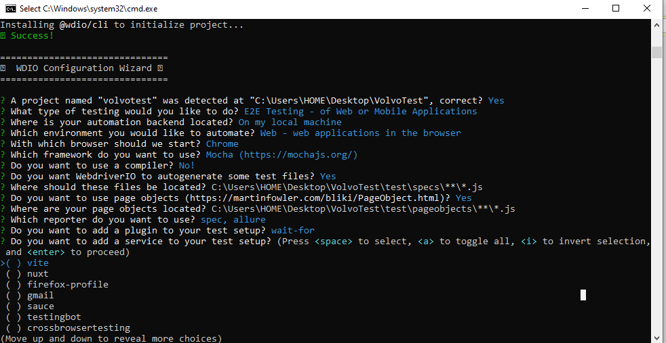Then just press enter because we don’t to add a service for now.
* 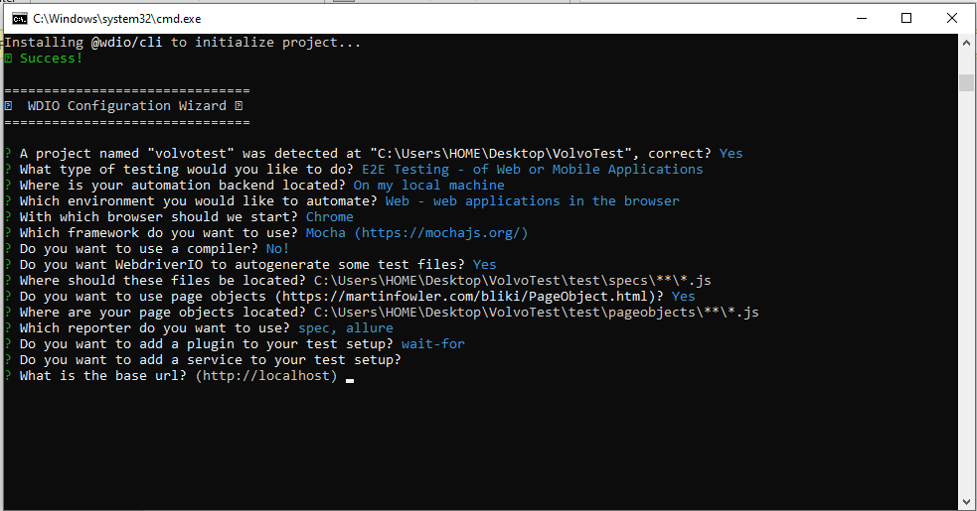Press enter for the default localhost or url
* 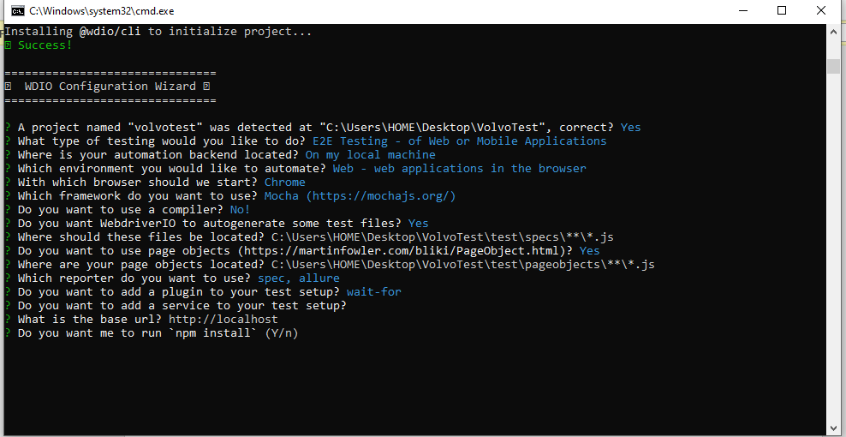Yes or Press Enter because we need to npm install so we can install the node_modules.
* 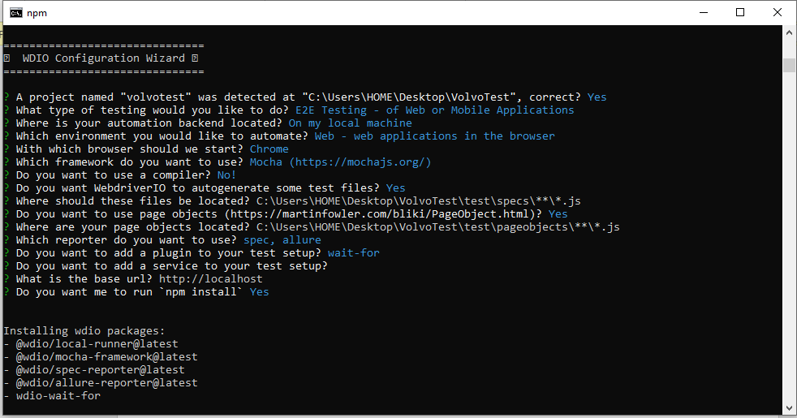As you can see it will download all the libraries that we choose.
* 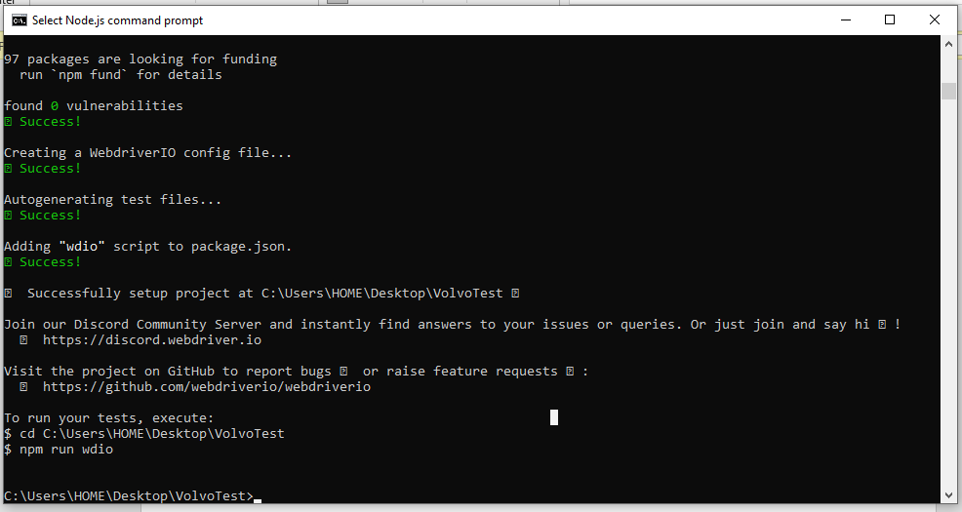Once you see this , It means you’ve successfully created a WebDriverIO Project
* 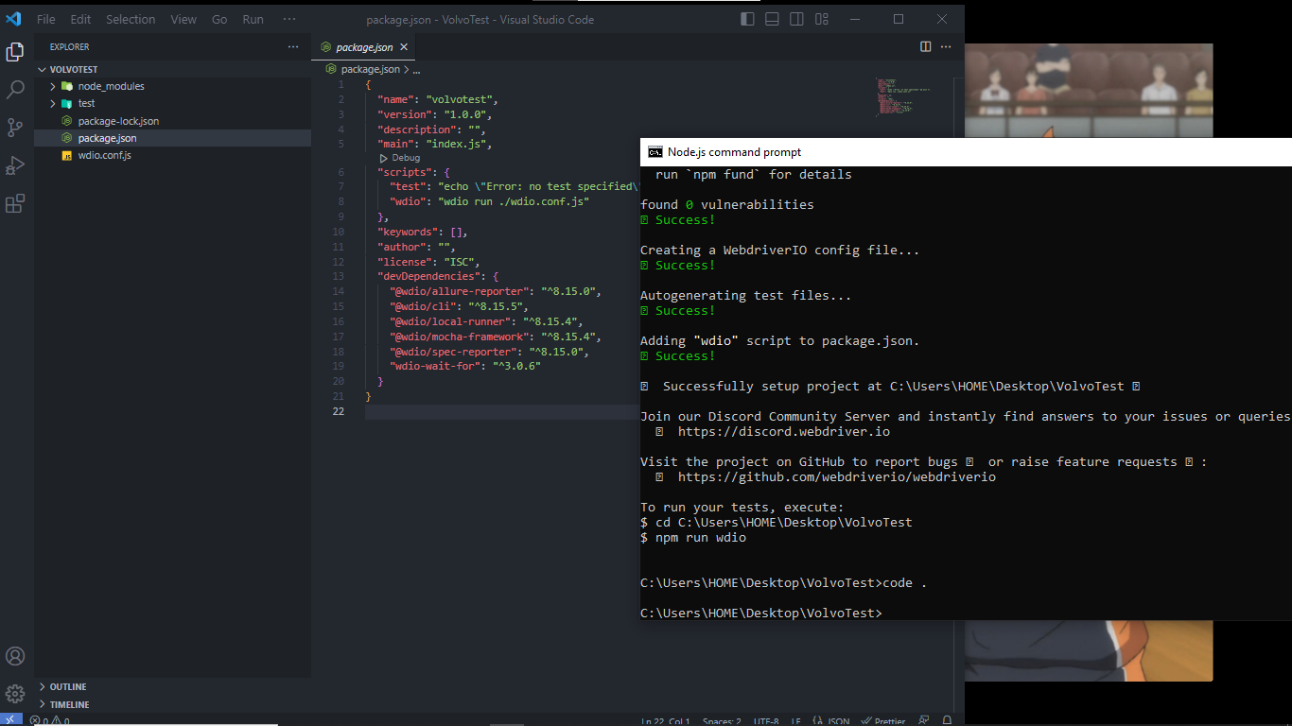Then just type code . in the nodejs terminal. Then vs code IDE will automatically open.